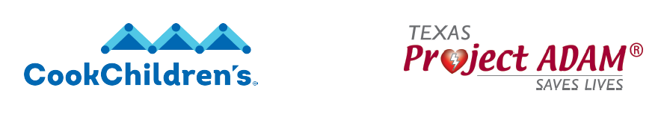

How to become a Project ADAM Texas Heart Safe School
Does your school have an AED? Do you know where it is and how to use it? If a sudden cardiac arrest happened on your campus, would you be ready? Take the steps today to become a recognized Project ADAM Texas Heart Safe School!

- Complete a Heart Safe School Checklist to see which requirements you have in place, which ones you need and which ones you need help on.

- Return the completed Project ADAM Heart Safe School Checklist to ProjectAdamTexas@cookchildrens.org. Don’t worry about the requirements that aren’t in place or the ones you need help on. Your Project ADAM Texas Coordinator is here to help.

- Next, your Project ADAM Texas Coordinator will schedule a phone call and/or follow up meeting to discuss what’s not in place and what’s needed to meet the missing requirements. We have the templates for you to fill in/create your school’s Cardiac Emergency Response Plan, and everything you need to conduct your AED drill, including the AED Drill Checklist and detailed instructions on how to conduct a drill.

- Once you meet the necessary requirements on the Heart Safe School Checklist, schedule and conduct your AED drill and fill out your AED Drill Checklist. It’s normal to be nervous about conducting your first drill, and Project ADAM has step by step instructions to guide you through the process.

- Email/fax your completed Heart Safe School Checklist and AED Drill Checklist to ProjectAdamTexas@cookchildrens.org after your first drill and you will officially become a recognized Heart Safe School!

- You will receive a Heart Safe School certificate, Heart Safe School banner, be added to our community of Heart Safe schools on our website and receive ongoing support from your Project ADAM Texas Coordinator.

- Each year, we ask that you review your Cardiac Emergency Response Plan, conduct at least one AED drill, fill out and send an AED Drill Checklist back to ProjectAdamTexas@cookchildrens.org, conduct all staff annual awareness education (ask your Project ADAM Coordinator for a complete script!) and submit your online annual form by December 31st so we can stay in touch with your school. Continue to check your AED monthly/per manufacturer directions, document each check, track and/or update CPR/AED training for your Cardiac Emergency Response Team annually/every two years.

- We hope you never have to use your AED. However, one of the benefits of being a Heart Safe School is free pad replacement in the event you do have to use it. Cook Children’s will provide you with an AED Report Form if and when an emergency happens. Email/fax this form to ProjectAdamTexas@cookchildrens.org after the event and we will replace your pads for FREE!

- Still not sure about some of the requirements and/or the process? Need help providing all staff awareness education/hands only CPR/AED training? Ask your Project ADAM Texas Coordinator. We’re here to provide you with everything you need to become a recognized Heart Safe School.

