 | 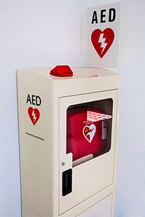
  June 2023
  What's Inside
  - National CPR/AED Awareness Week
  - Access to AEDs Act
  - Kids Save Lives
  - Team Heart Video
  - Hero Spotlight: 6th Grader Saved
  - Heart Safe School Spotlight

National CPR/AED Awareness Week
June 1-7 was National CPR/AED Awareness week and here at Cook Children’s, we celebrated big time with our very FIRST Annual Sidewalk CPR event! Click on the picture below for a fun video of the event, courtesy of our Cook Children’s Public Relations team.
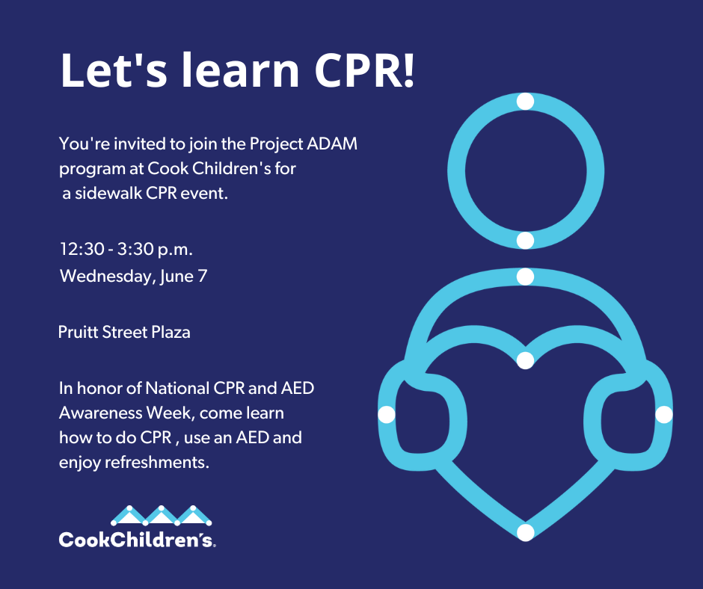

Access to AEDs Act
The Access to AEDs Act (H.R. 27230/S. 1024) was recently introduced in Congress. This bipartisan legislation would direct the Department of Health & Human Services to award grants to elementary and secondary schools partnered with a nonprofit health care organization to develop and implement a comprehensive program to promote defibrillation access. Grants could be used to purchase and maintain AED and CPR equipment, provide training, develop a cardiac emergency plan and more – much of which aligns well with the efforts of Project ADAM affiliates across the country. We’re pleased to share that the Project ADAM National Office has sent a letter to the bill authors and Cook Children’s is working with our legislative team to explore what we can do. Click here to read the full bill.
Kids Save Lives
Kids are sponges but are they ready to learn CPR and how to use an AED to potentially save someone’s life? The American Heart Association recently released a publication which supports this idea and goes on to say “Young children from 4 years of age are able to assess the first links in the chain of survival. By 10 to 12 years of age, effective chest compression depths and ventilation volumes can be achieved on training manikins.” Read all about it here.
Team Heart Video
Has your school ever considered doing an awareness video for students on your AED(s) and emergency plan? One Heart Safe School in our program, Teravista Elementary in Round Rock ISD, did just that. Click on the picture below to watch their video and consider creating your own school video this coming school year to educate your students.
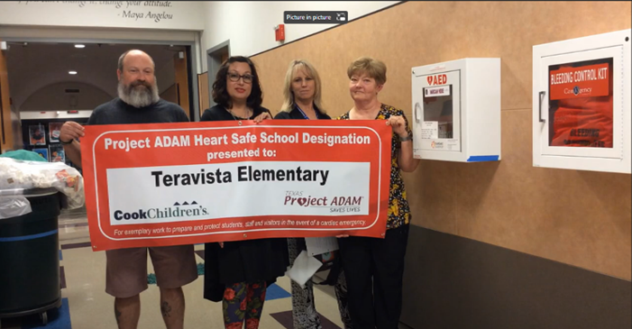

Hero Spotlight: Sixth Grader Saved
When 13-year-old student Cade Weaver collapsed just after PE class, staff immediately started chest compressions and called for the AED. Mom said “His defibrillator shocked him 9 to 14 times, and they all failed. The compressions they did could not have been more perfect. Doctors don’t think he suffered any hypoxia or any effect on his brain. Everything while he was down was moving — because of those compressions. And right before EMS arrived, Cade took one big deep breath.” This story had a happy ending thanks to the quick action this school took. Click on Cade’s picture below to learn more about this heartwarming save.

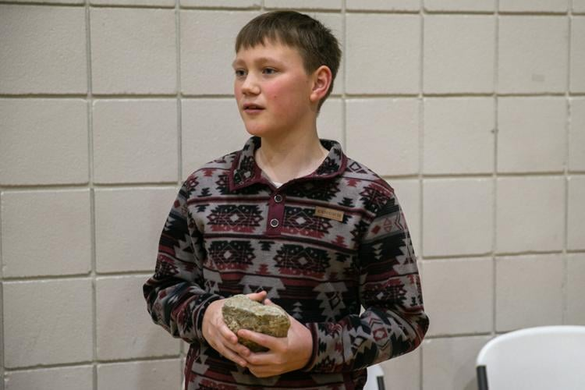

Heart Safe School Spotlight

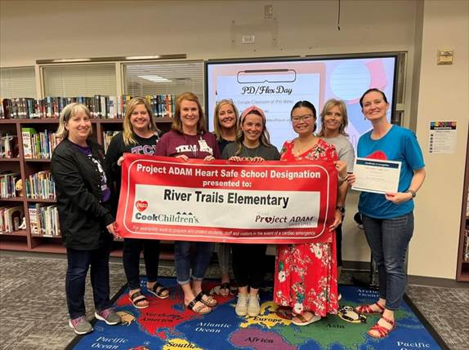
It’s been a busy end to the school year! Join us in congratulating our newest Project ADAM Heart Safe School District, Cleburne ISD, and the following Heart Safe Schools who joined our Project ADAM program at Cook Children’s this spring:

Snyder Primary School | Harrison Lane Elementary
Buinger CTE Academy  San Jacinto Junior High School  Hurst Hills Elementary  Midland Freshman High School  Denton High School  Frasier Middle School | Bellaire Elementary  Ponder Elementary  Arbor Creek Elementary  Poteet High School  Wilkinson Middle School  Woolley Middle School

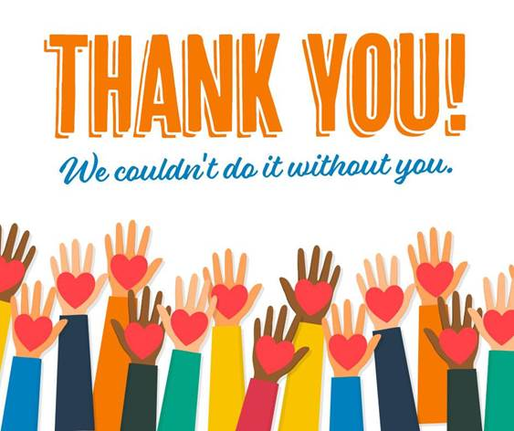\

Project ADAM’s mission is to educate school systems, nurses, coaches, trainers, parents, and others about pediatric sudden cardiac death.
Project ADAM helps implement public access defibrillation programs (PAD) across Texas and the nation. Our goal is to increase awareness of sudden cardiac death and establish emergency programs that provide a timely and lifesaving response. Since 2011, our Project ADAM program at Cook Children’s has recognized 628 Heart Safe Schools and 24 Heart Safe School Districts.



