 | 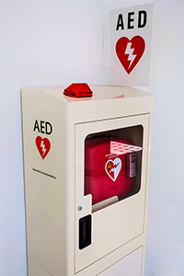
  October 2023
  What's Inside
  - Sudden Cardiac Arrest Awareness Month
  - Heart Safe School Online Annual Form Due December 31st
  - New School AED Drill Video
  - NFL CPR/AED Education Beyond The Field
  - Prosper Summer Safety Event
  - Hero Spotlight: Marathon Mom Saved In McKinney
  - Heart Safe School Spotlight

Sudden Cardiac Arrest Awareness Month
October is Sudden Cardiac Arrest (SCA) Awareness Month and to celebrate, we kicked off another social media awareness campaign on our Project ADAM social media pages. If you aren’t already tuned in to Project ADAM on Facebook and Instagram, click on the picture below to follow us and learn about cardiac arrest, CPR, AEDs and more.
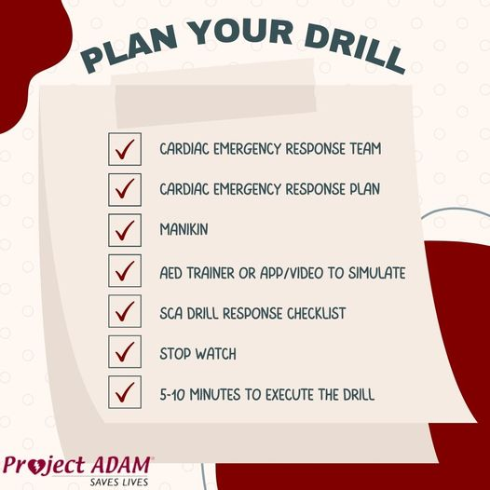
Heart Safe School Online Annual Form Due December 31st
There’s just a few months left to submit your online annual form, verifying that you’re still an active Heart Safe School in our program. Schools who submit the form must answer yes to all 5 annual requirements and upload a copy of an AED Drill Checklist from drill performed sometime between January 1 - December 31, 2023 in order to receive a 2023 heart sticker for their banner. If it’s been 3 years since your school submitted your Heart Safe School Checklist, you’ll need to upload an updated copy. Have questions or unsure if it’s been 3 years since your school submitted the Heart Safe School Checklist? Email ProjectAdamTexas@cookchildrens.org and we’ll check. Click on the picture below to access the online annual form. Don’t miss out!
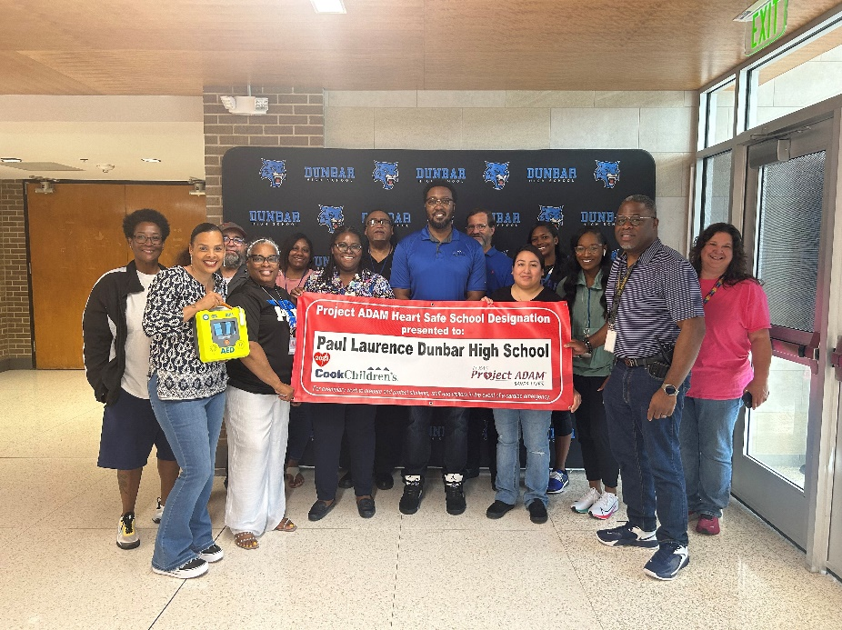
New School AED Drill Video
Many schools have never done an AED drill before and it can be nerve-wracking not knowing what it looks like or how to run one. Thanks to our friends at Nicklaus Children’s Hospital Heart Institute, we now have a brand new school AED drill for you to show your school’s emergency team so they can feel better prepared to run their next drill. Check out the drill video on our Project ADAM YouTube channel by clicking on the picture below.
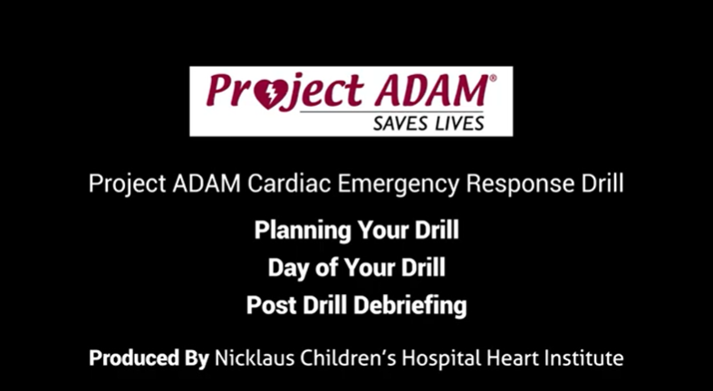
NFL CPR/AED Education Beyond The Field
Monday Night Football took a sharp turn when Damar Hamlin collapsed on the field. Then LeBron James’ son, Bronny James, went into cardiac arrest and collapsed at basketball practice at University of South California in July. In both instances, there was a trained team who immediately responded, did CPR and used an AED to bring Damar and Bronny back to life. ESPN went on to create a new “Lifesaving” video when Los Angeles Rams football coach, Raheem Morris, was able to use the CPR/AED training he learned on the field to save 3 year old Wyatt. Watch this inspiring video by clicking on the picture below.
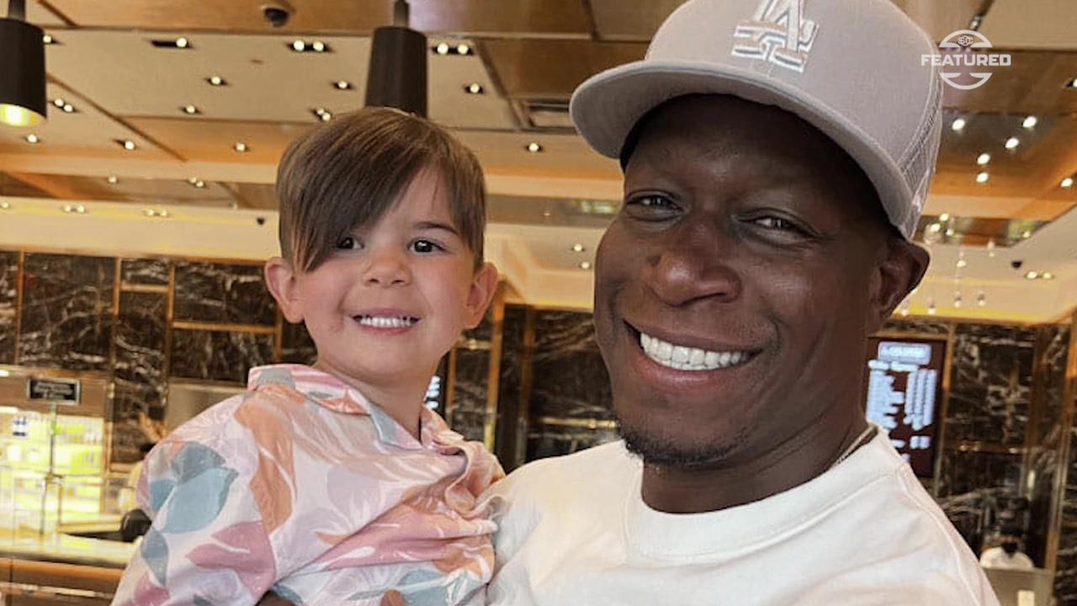

Prosper Summer Safety Event
In June we celebrated CPR/AED Awareness Week with our First Annual Sidewalk CPR Event. Then in July, Project ADAM took things up a notch and invited our friends from Prosper Fire Department, Cook Children’s Health Plan, Cook Children’s Prosper Car Seat Safety Technicians and Spiritual Care to host a Summer Safety Event at Cook Children’s Medical Center Prosper. Click on the picture below to see more pictures from the event on our Cook Children’s Instagram page.

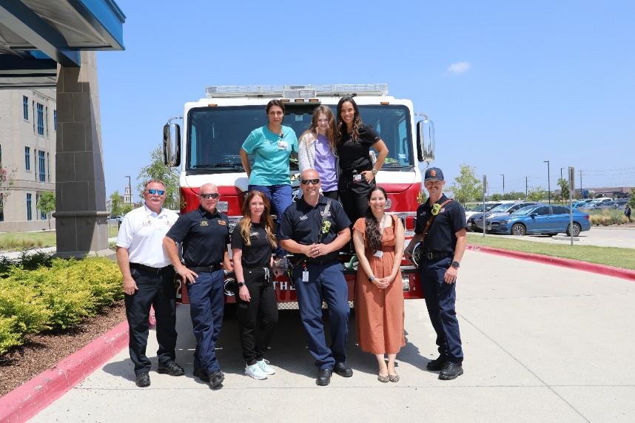

Hero Spotlight: Marathon Mom Saved In McKinney
We always talk about Heart Safe Schools and the importance of early recognition, early response and early defibrillation in the cardiac chain of survival. But what about cardiac arrests that occur outside of school in the community? Jaimee Kirby, young wife and mother of 3, was an athlete most of her life, preparing to run like she always did, in a half marathon in McKinney. The last thing she remembered saying was, “I’m going to have to stop, my heart’s going too fast.” Next thing she knew, she woke up in the hospital. Fortunately for Jaimee, thanks to her fellow runners’ early recognition and CPR efforts and McKinney Fire Department’s use of the AED, Jaimee is still with us today. Click on her picture below to learn more about this heartwarming save.

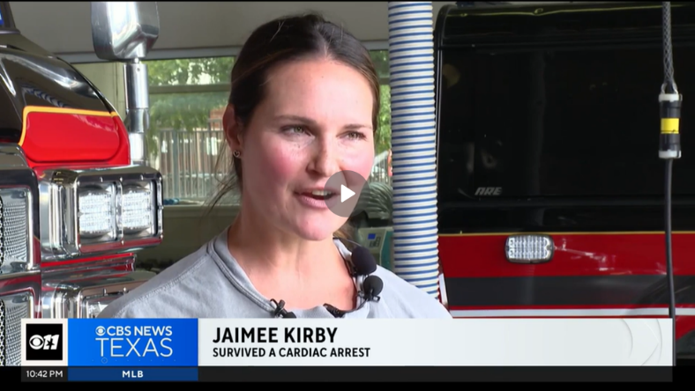

Heart Safe School Spotlight

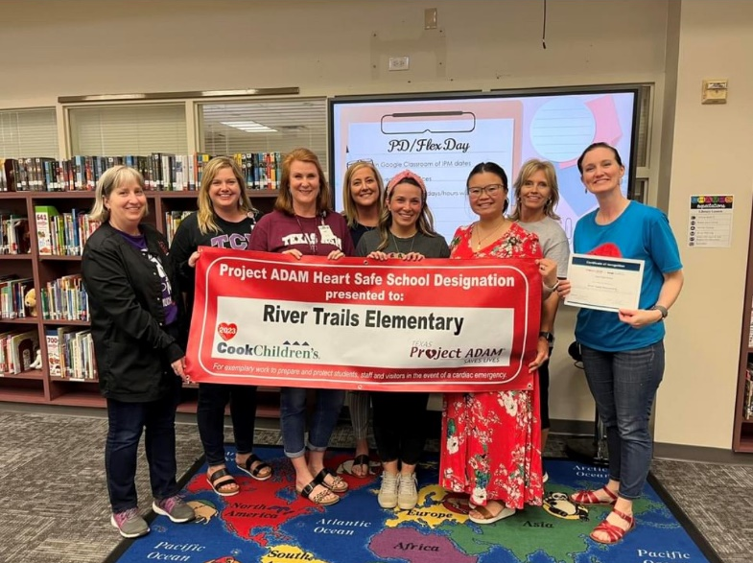
It’s been a busy start to the school year! Join us in congratulating our newest Project ADAM Heart Safe Schools:

Fort Worth Christian School | Agnew Middle School
Saint Andrew Catholic School  Young Women’s Leadership Academy  Vanguard High School  North Mesquite High School  Shands Elementary School  McKenzie Elementary School  Newman Smith High School | Motley Elementary School  Las Colinas Elementary School  Henderson Elementary School  Kent Elementary School  C.W. Worthington Middle School  Johnie R. Daniel Elementary School

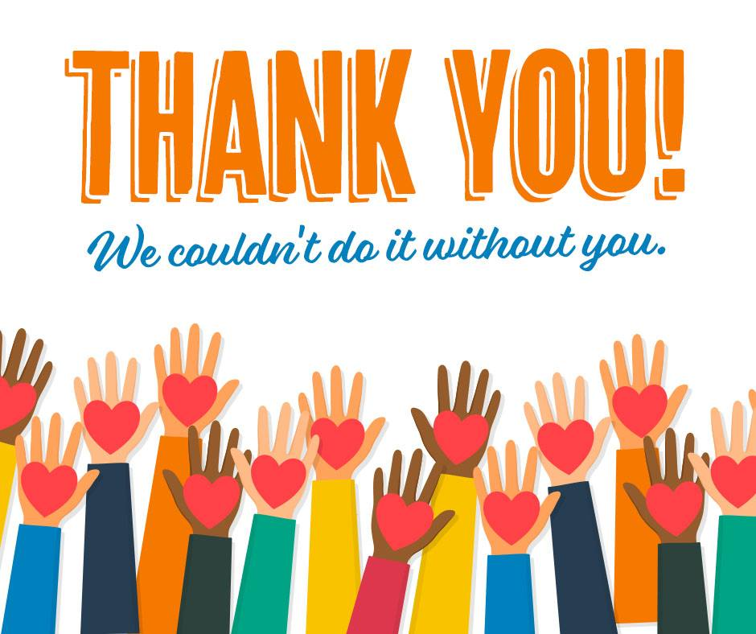

Project ADAM’s mission is to educate school systems, nurses, coaches, trainers, parents, and others about pediatric sudden cardiac death.
Project ADAM helps implement public access defibrillation programs (PAD) across Texas and the nation. Our goal is to increase awareness of sudden cardiac death and establish emergency programs that provide a timely and lifesaving response. Since 2011, our Project ADAM program at Cook Children’s has recognized 628 Heart Safe Schools and 24 Heart Safe School Districts.



