Cook Children’s Pain Management
1500 Cooper St.
Fort Worth, TX. 76104
682-885-7246

Patient History Form

Date of first appointment ____/___/____ Time of appointment _____________________

Name: ________________________________________________ Birthdate: _____/_____/_____
Last First Middle

Address: ___________________________________________________ Age: ______ Sex: F / M
Street Apt #

______________________________________________________ Telephone: Home (___)__________
City State ZIP Work (___)__________

The name of your Child’s primary care physician:_____________________________________________

Date when pain first began (approximate):__________________________________________________

In What part of the body did the pain begin: _________________________________________________

Under what circumstances did the pain begin: (please circle)

Accident Following surgery Following Illness Pain just began

Other:_____________________________________________________________________________

Briefly describe the circumstance(s) you circled. _____________________________________________

____________________________________________________________________________________

____________________________________________________________________________________

Describe briefly your child’s present symptoms ___________________________________________________________________________________

___________________________________________________________________________________

___________________________________________________________________________________

___________________________________________________________________________________

Please describe pain (circle all that apply)

Aching Pressure Stabbing Burning Prickling Throbbing

Dull Sharp Tingling Numbness Shooting

Other: ______________________________________________________________________________

Please circle what makes pain better:

Heat Ice Rest Lying down Weather/Temperature changes

Standing Sitting Medications Other: _______________________________________

Please circle what makes pain worse:

Walking Lifting Bending Lying down Weather/Temperature changes

Standing Sitting Other: ____________________________________________________

Please rate pain intensity on a scale from 0 = no pain to 10 = pain that requires a visit to the ER

Pain on an average day:

0 1 2 3 4 5 6 7 8 9 10

Most intensity pain has reached

0 1 2 3 4 5 6 7 8 9 10

Least intensity of pain

0 1 2 3 4 5 6 7 8 9 10

Prior Treatments (circle all that apply) Helpful Not Helpful

Surgery ________________________________ ___ ___

Nerve Block _____________________________ ___ ___

TENS ___ ___

Physical Therapy ___ ___

Occupational Therapy ___ ___

Biofeedback/Relaxation Therapy ___ ___

Chiropractic Manipulation ___ ___

Psychology/psychiatry ___ ___

Medical Acupunture ___ ___

Massage ___ ___

Other: _____________________________________ ___ ___

Surgeries Date

____________________________________________________________________________________

____________________________________________________________________________________
Physicians your child has seen for this problem

____________________________________________________________________________________
Name Phone number Fax number
____________________________________________________________________________________Name Phone number Fax number
____________________________________________________________________________________
Name Phone number Fax number

Any serious injuries? no yes if yes please describe: ______________________________________

Serious Illnesses? no yes if yes please describe: ______________________________________

Has your child received any diagnostic tests for this pain problem: exp: MRI, X-ray, CT, Labs, etc.

If other than Cook Children’s

Test Done Month/year Facility

____________________________________________________________________________________

____________________________________________________________________________________

____________________________________________________________________________________

____________________________________________________________________________________

Does your child have difficulty with?

Speaking Yes No
Vision Yes No
Hearing Yes No

If yes please describe: _________________________________________________________________

Does your child have developmental delays? If yes please describe.

___________________________________________________________________________________

____________________________________________________________________________________

____________________________________________________________________________________

____________________________________________________________________________________

Does pain disrupt sleep?

How long does it take for your child to fall asleep? ____________________________________________

Does pain wake your child from sleep? ____________________________________________________

What time does your child go to sleep and what time do they wake in the morning? _________________

____________________________________________________________________________________

Does your child drink caffeinated beverages? (Tea, soda, coffee, etc.) if yes cups/glasses per day? ___
Activities that your child is involved with. Please circle.

Sport – if yes, which sport ___________________________

Dance – if yes, type of dance_________________________

Band – if yes, which instrument_______________________

Gymnastic

FFA

Other – Please describe_____________________________

How many hours a week does your child participate in this activity including practice time? __________

School

Does your child attend school? No Yes

Grade level______________

Does your Child miss school due to pain? No Yes If yes how much? _________________________

Does pain keep your child from activities that they would like to participate in? If yes, please explain

____________________________________________________________________________________

____________________________________________________________________________________

____________________________________________________________________________________

What type of impact does your child’s pain have on the family? _________________________________

____________________________________________________________________________________

____________________________________________________________________________________

What are your expectations from the pain management team? __________________________________

____________________________________________________________________________________

____________________________________________________________________________________

____________________________________________________________________________________

PLEASE LIST ALL MEDICATIONS
Include over-the-counter medications

CURRENT MEDICATIONS | DOSAGE | FREQUENCY | PLEASE CHECK: HELPED?  A Lot Some Not At All

How many times a week does your child take over the counter medications for pain such as Tylenol, Ibuprofen, Motrin, etc.
____________________________________________________________________________________

Please list any/all medications your child has tried for their pain. (Example: Gabapentin (Neurontin), Amitriptyline (Elavil). Non-Steroidal Anti-inflammatories, Narcotics, Muscle Relaxants, Lyrica, Celebrex, etc.:

1. | 5.
2. | 6.
3. | 7.
4. | 8.

Medication Allergies? If yes, please list name of medication and reaction ________________________

____________________________________________________________________________________

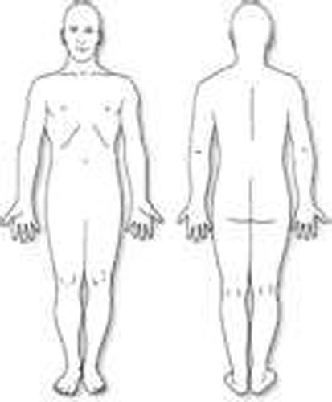 Please mark the location(s)
of your pain on the diagrams
with an “x”. If whole areas
are painful, please shade in
the painful area.

Are you: 􀂅 Right Handed
􀂅 Left Handed

R L L R

Right Left

